Problems in software
- Dashboard Issues:
- 
Dashboard entries like total parties total items total purchases total sales are blank.
- Quick actions pallet is working.
- Recent purchases and recent sales are displayed correctly. (Suggestions: we need to add filter there in dashboard recent purchase and sale to filter data according to item or date or month or a period.
- Business overview is just stock image and not a real time data. (Suggestions: we can avoid business overview on dashboard or in the app completely.)
- System status shows everything active and ok but needs investigation if it is actually working.
- There are two dashboards one is legacy dashboard (one early dashboard we designed) and other is modern dashboard. modern dashboard has again problems:
- The tiles shown at the top have text not aligned properly. It has to be fixed:
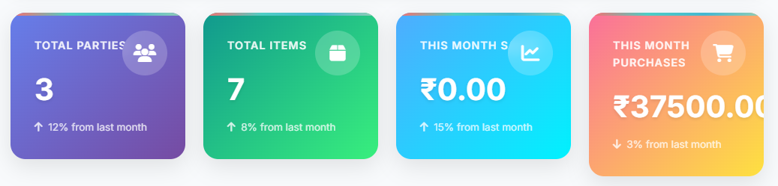
- Tiles in the system module status are not of same size and needs to be fixed. 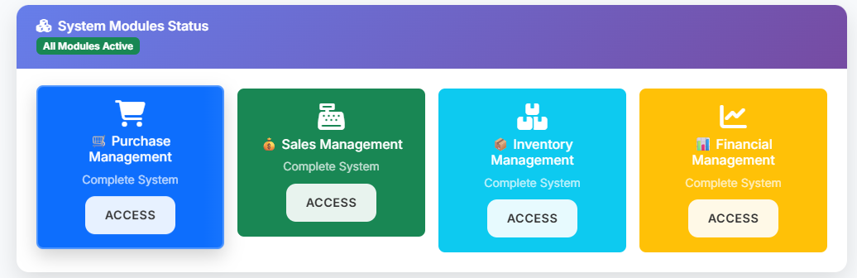
- The tiles in the system module status I think were temporary and were meant to be deleted after completion of development of application. There is again a quick action pallete which is to be kept and above is to be deleted:
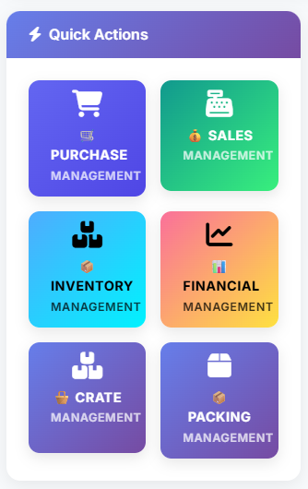
- Buttons are working in quick actions block.
- Sales vs purchase graph can be avoided as no real life use is there.
- Other tiles are stuck at loading needs to be fixed:
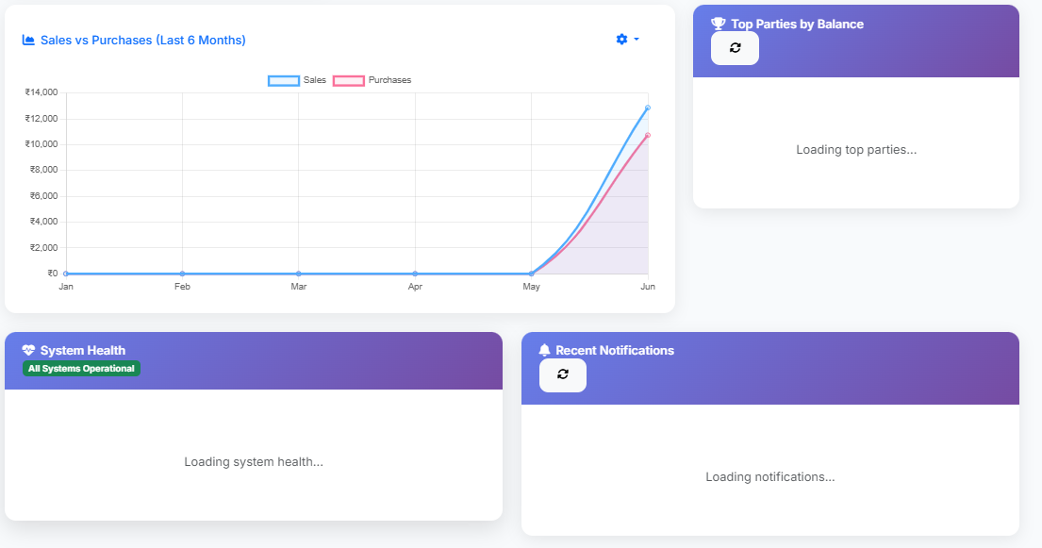
- We only need modern dashboard and legacy dashboard should be deleted.

- Purchase Management:
- The buttons at the very top are working:
- From above buttons when we click purchase order, purchase return, payment is form is opening but screen is deeming. (This issue is seen in lots of forms in the application)

- Now for purchase entry:
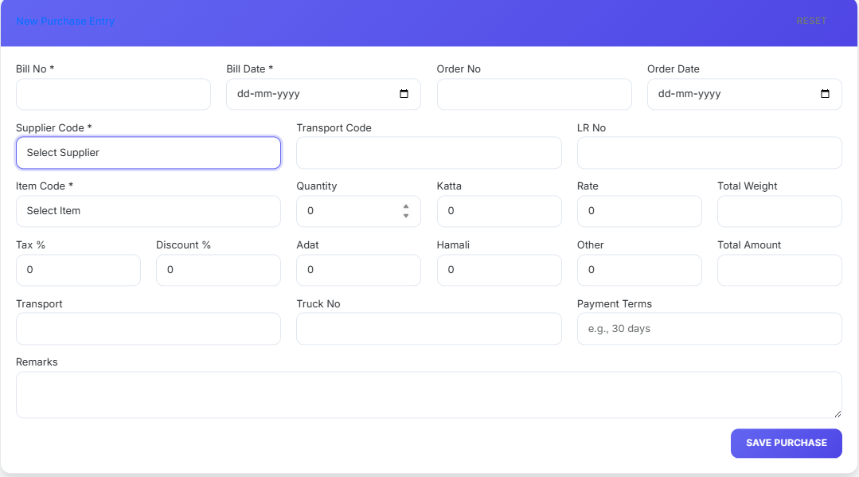
i. Bill number should be auto populated from the previous bill number. We have to establish a proper bill or invoice number pattern for each company.
ii. Bill date is not auto populating. It should populate with the current date automatically.
iii. Supplier code is not populating in supplier code dropdown.
iv. Item code is not populated in item code dropdown.
v. calculation logic is not working.
vi. Save purchase not working.
v. Problem number iv, v, vi were fixed recently but reappeared when we made some changes.

- Tiles at the top of purchase management are not updating in real time.
We don’t need growth tile there:
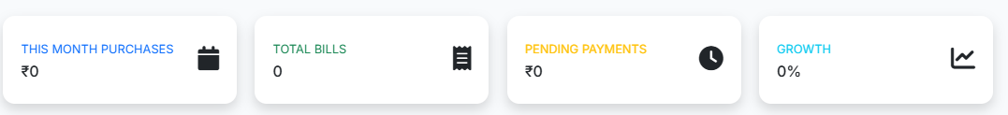
- Bill search is not working:
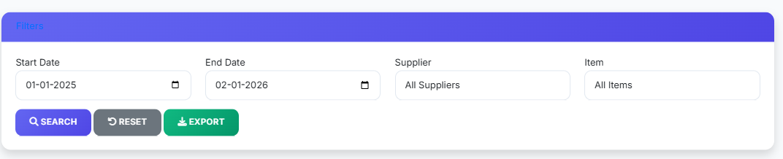
- Export function in bill search should export in excel and pdf.

- Sales Management:
- Sales management opening in new page and side panel is gone. We need it to open like other pages along with side panel.
Note: Font size of sales management appears good. We should adopt this style of all of application. It feels comfortable and workable.
- Info tiles at the top are not updating real time.
- Sales entry form not working.
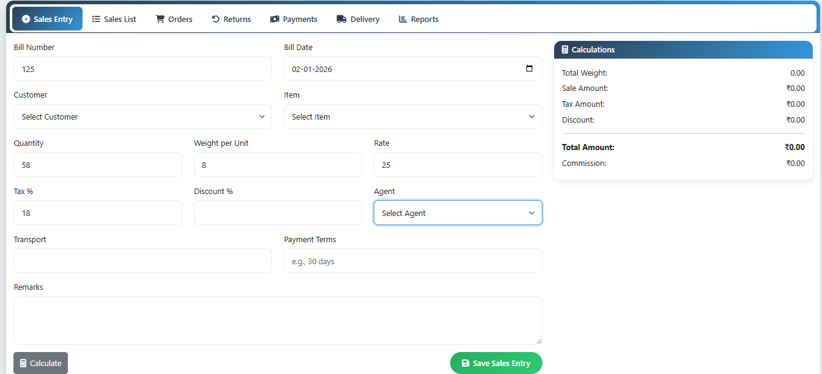
- Sales list is not working, orders form is to be implemented, Return form is to be implemented, payments form is to be implemented, delivery form is to be implemented, reports has to be generated in excel as well as pdf.
- Inventory management:
- Inventory management opens but side panel is hidden. Side panel should be visible while inventory management is open.
- Inventory item list is being populated but can be refined.
- Filtering in inventory item list working at category level but not working at item level.
- Stock movement is not working yet
- Low stock alert and reports are not working yet
- Financial Management:
- Financial Management opening without side panel. Side panel should be there in every page.
- Chart of accounts is working but filtering is not working.
- Journal entry is not working
- Ledger is not loading.
- Trial balance is not loading
- Balance sheet is not loading
- Profit and loss is not loading
- Crate Management System:
- Tiles at crate management showing data, but needs to be inspected for real time data update
- While opening new transaction the form appears but screen dims. Need to be solved
- New transaction form is loading but is off placed. When opened while the main page of crate management is open it opens but half visible. Means new transaction form is not moving freely independent of crate management form
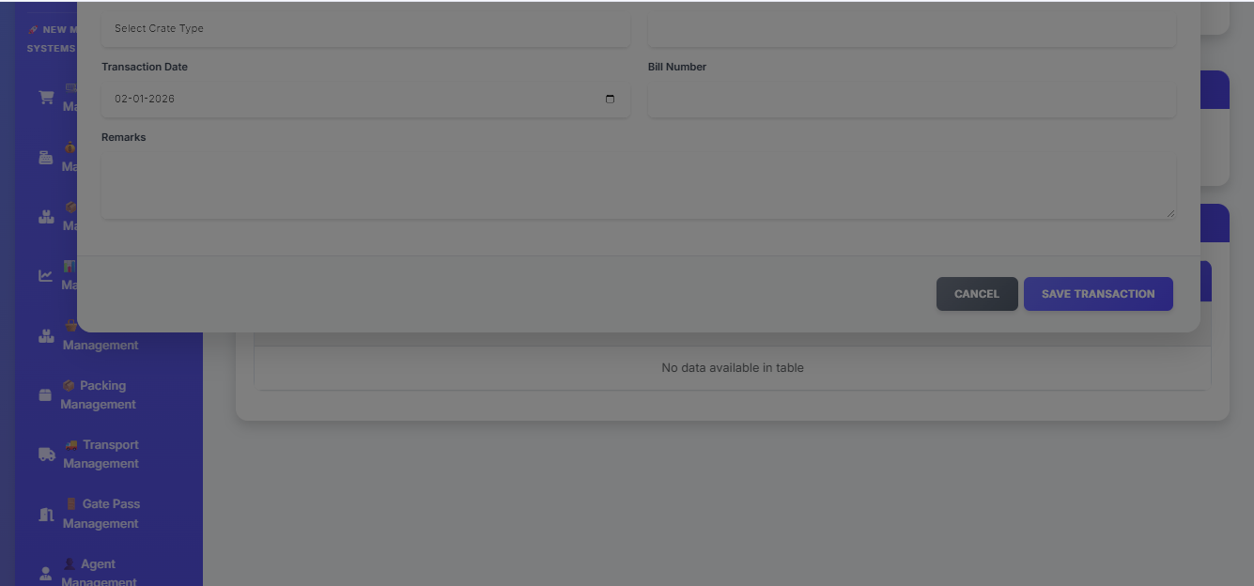
- Check balance, reconcile and export not working. Export is generating a excel file but is full of error
